AP CSP Python with Robots  Functions, Parameters and Variables Activity Guide |  | Name:
Introduction
During this assignment, you will discuss when a function needs parameters, local variables and global variables.
Warm-Up Reflect on the functions you have defined and used since Mission 3.
What is a function?
How do you define and call a function?
When do you use a function – what are its purposes?
Parameters and Local Variables Problems: List each variable. Indicate if it is a parameter or local variable. How is it used in the code? Insert more rows for each problem, as needed.
#1  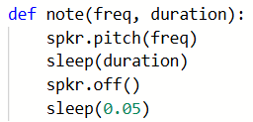 | Variable Name Type How it is used  freq parameter Argument in function call
#2  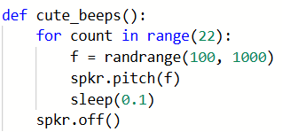 | Variable Name Type How it is used
#3  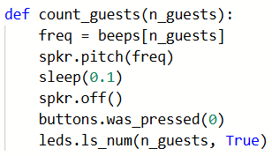 | Variable Name Type How it is used
#4  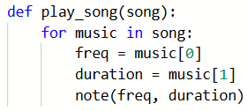 | Variable Name Type How it is used
#5  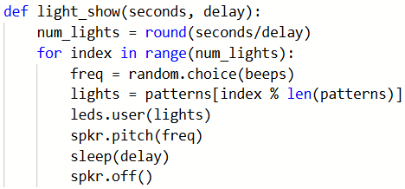 | Variable Name Type How it is used
Parameters, Local Variables and Global Variables Problems: List each variable. Indicate if it is a parameter, local variable or global variable. Insert more rows for each problem, as needed.
#6  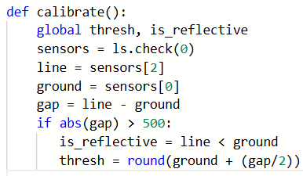 | Variable Name Type How it is used
#7  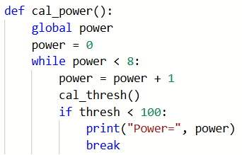 | Variable Name Type How it is used
#8  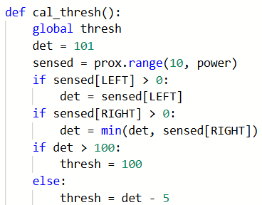 | Variable Name Type How it is used
#9  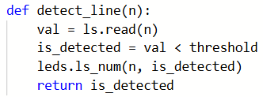 | Variable Name Type How it is used
#10  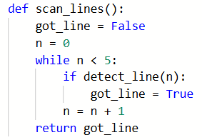 | Variable Name Type How it is used
Wrap-Up
Give two benefits of using functions? (How do they manage complexity)?
What is a parameter, and what are some reasons to use a parameter in a function?
What are local variables, and when would you use them?
What are global variables, and when would you use them?
Submit this assignment to the teacher.

